Fidaa Yaseen/Araj
Department of Urban and Regional Planning
University of Illinois at Urban-Champaign

Planning Under Deep Political Conflict:
The Relationship between Spatial Planning and the Struggle over Space in the Occupied Palestinian Territories/from the British Mandate to the Current Israeli Occupation

The mutual relationship between power relations and space has been crucial in the Palestinian/Israeli conflict. In other words, power has been spatially practiced in the Palestinian/Israeli conflict: space is used in the exercise of power, and it also releases and displays power. In this context power does not only related to power from above; the power to dominate, to control, to impose order from top downwards by the occupier. Rather it is also the power from bellow; the bottom-up power, the power of resistance by the Palestinian people. That is control is in a dyad relation with resistance, and space is the main arena of the practices of this dichotomy in the Palestinian Territories (PT).
In this struggle of control and resistance over space in the PT, different actors are involved using both built and open space: the Israeli occupation with its planning system; the Palestinian authority with its planning system; the Israeli settlers; and the Palestinian people. Since the beginning of the Israeli occupation, it has been enforcing different policies of using space (built and open) to achieve control over the Palestinians. The Palestinian authority with its planning system under the Israeli policies of control does not have enough power to deal with the different spatial problems that face planning endeavor. The Palestinian planners find themselves limited under the different Israeli policies of control, and their work is affected by the practices of the Israeli planning system whose main objective is to achieve control over the Palestinians.
Among the different actors in the spatial struggle in the Palestinian Territories are the Israeli settlers and the Palestinian people. The Israeli settlers’ role in this struggle over space can be conceived as agents to the Israeli occupational system of control. They conduct different practices of occupying the Palestinian land and buildings. The Palestinian people in this struggle over space, despite the different strategies to achieve control by the Israeli occupation, they continue their claim to their rights to use space through their own spatial practices.
Within this complex struggle over space between actors seeking control and those who resist that control and claim their rights to space, this study aims to understand the role of planning in dealing with this complexity by understanding the relationship between space, power, and planning. In other words, the research will explore the relationship between the struggle over space and spatial planning in the complex context of occupation.
Existing literature on the role of planning in the complex context of occupation is limited. Post colonial planning literature greatly, yet theoretically, addresses the problem of planning as becoming a tool to achieve control. It criticizes the application of western planning theories in non-western societies as an expression and means of such domination through planning (Yiftachel, 1995). Instead, this perspective calls for local, domestic, contextual planning. Additionally, debates within radical planning and insurgent planning approaches discuss planning in the face of control—(Beard, 2003), (Miraftab, 2008), (Holston, 2009), (Perera, 2009), and (Yiftachel, 2009). They discuss how in political contexts where domination is achieved through direct authoritarian rule or indirect inclusion, transformation can be achieved by the engagement of populace in a kind of covert and then radical or insurgent planning. For this literature, this engagement is a kind of insurgent practices or actions. The main characteristic of these practices to be considered ‘insurgent’ is ‘informality’, and the main objective is to ‘destabilize’ the hegemonic regime whether through practices of “insurgent citizenship” in the face of “differentiated citizenship” (Holston, 2009), or through practices of disrupting neoliberal governance (Miraftab, 2008), or processes of space-making through ordinary people over any official plan (Perera, 2009), or by settling excluded in the shadow of formal spaces; in “gray spaces” (Yiftachel, 2009).
However, this literature is dealing with conflict between authoritarian state and its citizens of minorities and social groups, not a state of occupation and another occupied (local) state and occupied citizens. In an occupied or colonial area there are two systems of planning: the local planning system and the planning system of the occupation. In this context the occupying planning system is operated to achieve control of both local state and local people, mode of ruling that produces complex difficulties facing the local planning system. Therefore, how can the local indigenous planning system operate resisting control of the occupying planning system?
In this context, this paper aims, by examining planning authorities and citizens whose decisions are constrained by the rule of the Israeli state, to unfold the multiple layers of complex politics involved in spatial planning as means of social control. It explores the role of indigenous planning and occupying planning in occupied areas. It hopes to result into conceptual contributions for spatial planning in the PT. The conceptualization of this research will provide an understanding for future studies about planning in cities under deep political conflict such as occupation. It will develop the idea of ‘planning as a form of resistance’ or ‘resistant planning’.
The significance of this research lies in its addressing lack of knowledge about planning within the complex context of colonial/occupational areas. It has practical and conceptual contributions. Practically, it documents processes and decisions of planning under occupation. Conceptually, the study contributes to scholarship in planning and political geography by illuminating the spatial practices of different actors in their spatial struggle. To planning scholarship it adds voice to those who have called for an expanded definition of planning. That is planning is not limited to practices of trained professionals. Rather it includes everyday spatial practices of people that are powerful in shaping the space and its territorial control.
Palestine has a long history of occupation and domination. Thus the phenomenon of the use of spatial planning in the struggle over space in the Palestinian areas is historically rooted. Both open and built spaces have been the arena of the practices of the dyad control/resistance by the different actors across the long history of Palestine. This paper mainly focuses on the use of open space in the struggle in two distinct colonial periods: the British Mandate in Palestine and the current Israeli occupation.
To achieve its goals, the paper is structured in three main sections. The first one is giving an overview of the complexity of the struggle over space in the PT. It illustrates the use of open and built space by different actors for control and resistance in the Israeli/Palestinian conflict. The second section is a historical study of the use of open space through afforestation policies in the struggle during the British Mandate period in Palestine, and in the current Israeli occupation period returning back to its early periods. The main argument is that the British afforestation planning helped in the establishment of the Israeli state with its Jewish nation in Palestine. At the same time, the Israeli afforestation policies inherited and developed from the British legacy, maintain and protect the existence of the Israeli state. Recognizing the role of afforestation planning in the struggle, the Palestinians (government, groups, and individuals) are applying a policy of resistant-afforestation-planning; or indeed resistant-agricultural-planning. The significance of this policy is that it is not only embraced by the Palestinian citizens; the ‘unprofessional’ Palestinian people. Rather it is also encouraged by the professional Palestinian system through the engagement in a cooperative work between the government and the civil society, and by using a kind of “covert planning” to achieve more power. Finally the paper ends with the concluded remarks.
- The Complexity of the Struggle over Space in the Palestinian Territories:
Four main bodies of actors are in the struggle over space in the Palestinian territories: the Israeli occupation with its planning system; the Palestinian authority with its planning system; the Israeli settlers; and the Palestinian people. Each body has its own spatial practices the thing that adds to the complexity of the struggle over space which in turns makes planning a complex task. There is an intertwined pattern of control/resistance using both open and built spaces among the groups of actors.
The Israeli occupation uses both built and open spaces as an arena to achieve control over the Palestinians. It imposes different policies to achieve this control. Policies that focus on built spaces to achieve control are: building regulations and building demolition policies, encroachment or ‘closure’ practices over specific buildings, and the policy of construction and destruction. Through long periods of curfews the Israeli occupation prohibits the Palestinian people from using commercial buildings as a way to undermine the Palestinian economy and to attack the Palestinian people by cutting their daily needs. The Israeli occupation also imposes the policy of occupying specific buildings (public buildings or private houses) and transferring them into military points, and closing specific public buildings such as schools and universities.
Most importantly, the Israeli policies using built-up spaces as an arena to control over the PT includes construction as well as destruction. Parallel with damaging, destroying, occupying, and restricting different kinds of the Palestinian buildings, the Israeli occupation is busy in building huge numbers of Israeli settlements and a network of bypass roads to connect them over the Palestinian land, see Fig. (1). The Palestinian built-up spaces are not the only arena to achieve control for the Israeli occupation, but also open spaces inform a vital arena for that control.
Policies that focus on open spaces to achieve control include the repeated occupation of main squares and plazas in the Palestinian cities, and the ‘internal closure’ policy. Using open spaces in the PT as a way to achieve control for the Israeli occupation was sustained by zoning the West Bank into a confusing mosaic of pieces of territory through Oslo II agreement in 1995 see Fig. (2) bellow. Since 2000, the Israeli occupation has prohibited the Palestinian people from using most routes that connect the Palestinian cities by enforcing, in addition to the external closure, continuous intensive policies of internal closure and movement restrictions. The ‘external closure policy’ has been imposed upon the Palestinians since 1990s, in which they are forbidden from entering the Israeli areas without pass permission. But through the ‘internal closure policy’ the Israeli occupation has forbidden the Palestinian people from free movement within the Palestinian Territories, using large number of checkpoints and road blocks, see Fig. (3).
The Palestinian planning apparatus consists of three levels: the Higher Planning Council (HPC), the Regional Planning Committees (governorates level) and the Local Planning Committees (municipal and village councils). Planning responsibilities are divided between the Ministry of Planning (MOP) and the Ministry of Local Government (MOLG). The MOP is responsible for the physical planning issues on regional (the West Bank and Gaza Strip) and national levels, and the MOLG took the responsibilities of planning at the local level (municipalities and village councils) within the areas under the PT control (zone A and zone B). Despite the great effort done within these institutions to manage planning issues, Palestinian planners are working with great limitations and constraints. They, affected by the Israeli planning system, do not have enough power to deal with the different spatial problems facing them. For example, this appears in the in-successful attempts of the MOLG in its work of preparing the needed structural plans for local communities. In these attempts, they were affected by the conditions of lack of autonomy, limited power to take decisions, and working under the Israeli occupation restrictions and forces; specifically related to zoning the PT into zones A, B, and C, in which most of the Palestinian communities are within zone C.
The Israeli settlers in this struggle over space are the agents for the occupational system in order to expand and strengthen control over the PT. In this agency, they use both the Palestinian built and open spaces. They attack Palestinian buildings and claim their rights to these buildings. The historical struggle in Al-Khalil (Hebron) and Al-Quds (Jerusalem) cities is a good example of these attacks. In Hebron, hundreds of Palestinian families lost their homes, or even their lives, because of the settlers’ attacks. Palestinian lands are also subject to settlers’ attacks that consist of tree-uprooting, cutting, and burning, or damaging and bulldozing the agricultural land.
Palestinian people, however, while under different policies of occupation for control and domination, have continued claiming their rights to the use of space (built and open) through their own spatial practices. They informally invent ‘alternative’ spaces (built and open) for their use instead of those spaces that are prohibited from their use by the Israeli policies. For example, when schools and universities are closed by the Israeli occupation, the Palestinians use alternative buildings for education such as the mosques, centers of private or semi-public organizations, clubs and even houses. Additionally, the Palestinian people use a local indigenous network of ‘bypass roads’ to turn around the Israeli checkpoints and roadblocks—these roads known for the Palestinians as ‘the substitutive road networks’. They use the agricultural roads that connect farmlands together which are not prepared for automobiles or even pedestrians to move from one place to another. They walk through agricultural land and mountains to move from one place to another avoiding the Israeli checkpoints even though this journey through mountains will take a long time and is full of danger.
As a result of the different policies of using built and open spaces to achieve control by the Israeli occupation, different problems have emerged in the PT that put the Palestinians under endless suffering, at the same time constraint the Palestinian planning system. These problems include: damaged and destroyed cities that need huge abilities for reconstruction; limited availability of land needed for future development; shrinkage of open spaces as a result of the repeated occupation of roads and squares, creation of Israeli settlements over the Palestinian lands and use of huge network of bypass roads to connect them; making access to open spaces difficult as a result of open space closure the very policy that affects both the Palestinian space and time, making them wait for long periods at checkpoints to reach their destinations. In addition Palestinian environments experience general physical damage and defacing caused by the repeated military operations using the policy of ‘bulldozing whatever on their way’; and are subject to pollution: air pollution, visual pollution, and sound pollution. It is through these spatial practices of the Israeli state that Palestinians planners’ task is made excessively difficult.
- Forestry: A Policy to Build a Nation:
Afforestation in Palestine historically reflects—and was used to achieve—the beliefs of the people who live in it, or indeed, contest to live in it. As a result, planting and afforestation in Palestine are used as a tool to conquer the land. There is an intensive competition for land in Palestine; a struggle that transformed into a form of ‘war’, and its tools or ‘weapons’ are the trees (Cohen, 1993). Thus, afforestation in Palestine is used historically to impose control, and at the same time to assist the resistance and to claim rights of the land.
Planting trees (and other agricultural activities) is used in the struggle over space as a permanent and vital method to establish presence on the land, to prevent encroachment, and then to conquer and control it. This struggle to achieve “presence” on the Palestinian land stems from the ideological basis of the actors involved in the struggle: the Israelis and the Palestinians. The symbolic power of using planting in the struggle over space is connected to the ideology of land of the participants; to their cultural framework in terms of the meaning of trees and their significance, and the meaning of the land and the practices related to it.
Both the Israelis and the Palestinians have religious, historical, social, economic, and political reasons that are different from each other (Cohen, 1993). Religious reasons for the Israelis stem from the idea that landscape and nature consciousness is related to their long-standing national goal of ‘to make the desert bloom’, along with the sense of pioneering that accompanies it (Cohen, 1993). For the Palestinians, religious attachment to the land stems from Islam. Muslims are encouraged by both the Quran—the Islamic holy book—and Prophet Mohammad to work and cultivate the land. Land in Islam is God’s blessing. Thus, working in the land is a kind of thankfulness and worship.
An effective concept in the struggle over space for both the Israelis and the Palestinians is the concept of homeland. This concept has a broader base on both sides to claim Palestine/Israel is a homeland for a nation. Stemming from the Zionist ideology, the Israeli people believe that Palestine is the “land without a people for the people without a land”. Their ambition was to transform the urban Jewish communities of Europe into an agricultural, pioneering society. This was to be achieved through a return to their homeland in Palestine, and the establishment of an agrarian regime (Cohen, 1993). Thus, settling and working the land is crucial in this ambition. Although the Jewish population has become overwhelmingly urban, the notion of the land, of settlement, and of “Jewish agriculture” still has considerable power. And, as stated by Cohen (1993), in modern days the Israeli government embraced—and legislated—an inalienability of land that is in their hands. For the Palestinians Palestine is their historic land. Despite the displacement and encroachment that has accompanied the Israeli occupation of Palestine, the belief of Palestine as their homeland has not changed and developed for both the Palestinians who live in Palestine or those who live in exile. They nurture considerable attachments to the land as they believe it existed in 1948. The Palestinians in the West Bank for example have experienced a continuous presence rather than displacement, and this presence is a key element in their identity. For them this continuous presence on land is a “sumud” (the steadfastness) which is crucial to claim their rights to the land.
As a result, afforestation and planting in Palestine have become at the core of the struggle over space. Trees have become the most efficient way of preventing land alienation. They are used to create or maintain, and demonstrate a hold on the land. Trees are used to impose control (by the occupier), and at the same time they are used to resist occupational control and maintain land rights by the Palestinian local people. The use of afforestation in Palestine in the struggle over space has continued in its long colonial history. In this section, I analyze the ways afforestation is used to achieve control and to resist that control in the two colonial periods of Palestine: the British Mandate (1917-1948), and the present Israeli occupation (1948-present). By analyzing afforestation policy and its use in each period, I highlight the ways in which afforestation helped build—and support the existence of—the Israeli state on the Palestinian land. The main argument is that afforestation has a great role in building a state and a nation.
- The Use of Afforestation in the Struggle over Space in the Mandatory Palestine, 1917- 1948:
During the British period, afforestation was used deliberately in the struggle over space. It was used to impose control to achieve desires and goals of the actors involved in afforestation: the British Mandate Government and the Jewish Communities, represented by the Agency of the Keren Keyemet L’Yisrael (KKL), the Jewish National Fund (JNF) as in Amir and Rechtman, (2004). At the same time, anti-afforestation policy had been used by the local indigenous population, the Palestinians, to resist this control. For the British, afforestation policy was used to impose control over the country in order to achieve economic and strategic goals. At the same time, it served the Zionist project. For the Jewish communities, it was in order to facilitate their settlement of the land. It was aimed to help in the Zionist project of a homeland in Palestine.
The British interest in protecting the remnants of natural forests of Palestine—through the establishment of, in 1920, the Forestry Service unit and the Woods and Forests Ordinance—parallel with the plantation of new ones had been for economic and strategic benefits of producing wood fuel. To produce wood fuel in Palestine with its strategic location to the British Empire, in an area that lacked this resource, and during difficult war-time, was so important, economically beneficial, and powerful for the British authorities. Moreover, the focus on olive industry—by passing the 1943 Olive and Control Ordinance and the creation of olive Control Board—was also motivated by their personal economic benefits as well as to control the Palestinian local economy to gain more power in the area. This goal had been so important for them without giving attention to the local population.
In their attitudes of producing a wide range of legislations, either for forest protection and reserves, or for restrictions of olive cultivation, the local people were excluded, and moreover, were limited, restricted and prohibited from development. Through the declaration of Special Areas and Forest Reserves by virtue of the forest and soil prevention ordinances—the Forest Ordinance of 1926 and its amendment in 1947, and the Flooding and Soil Erosion (Prevention) Ordinance of 1941—cultivation and agriculture were limited and could be prevented anywhere even on public or private land, and also building was limited; not permitted unless it did not cause soil erosion. The British legislations to control grazing—through Bedouin Control Ordinance of 1942—affected the life of the indigenous Bedouins, caused disruptions of their migratory habits and caused their sedentarisation.
Even when the British authorities included the local people in their policy, this was also for the British benefits. For example, training local indigenous people in forestry, and the involvement of the Palestinian villagers in the plantation work was because it was cheaper than using European professionals. As stated by El-Eini (2006), Sir Arthur Wauchope, the British High Commissioner in Palestine, recommended in the 1930s, training local staff rather than hiring “more expensive colonial foresters” (p. 195). Most importantly, this was a kind of ‘inclusion’ of the local people within the British policies in order to prevent any more conflict—governing by inclusion. This was noticeable in the decentralization attempts of forestry planning, through which specific power and responsibilities had been given to districts administration, though it was not fully applied and was contested by the Forest Department represented by its head Gilbert N. Sale (ibid).
The British afforestation policy in Palestine served the Zionist goals. The British insistent attitudes towards the declaration of Forest Reserves and the claims as being State Domain (see appendix 1 and 2) through the Forest Ordinances—the Forest Ordinance of 1926, its amendment of 1947, and the revised Forest Ordinance of 1948—had been the major factor that assisted land transfer to the Jews, basically because the majority of the declared land as Forest Reserves was Arab land. As stated by Cohen (1993), the Arab land reached 5 million dunams, while the Jewish land was 200,000 dunams (p. 54). The importance of this title to the Jews is indeed rooted in article 6 of the Mandate that the reserves would be given to the Jews. This article stipulated that “the government was to encourage the close settlement by Jews on State and waste lands” (see appendix 3) (El-Eini, 2006, p. 201). That is, more Forest Reserves as State Domain meant more land to the Jews. The vagueness of this system related to the use of colloquial descriptions of boundaries and the unclear ownership of land—in addition to those inherited from the Ottomans—had been exploited by the British government to more claim rights to land.
The focus of the British afforestation policy on the prevention of soil erosion—by the formation of Soil Conservation policy in 1939, the Soil Conservation Board in 1940, and the Flooding and Soil Erosion (prevention) Ordinance in 1941—sand dune fixation—through the 1922 Sand Drift Ordinance—and the control of grazing—through the 1942 Bedouin Control Ordinance—was crucial for the Zionist goals.
The prevention of soil erosion on the hills facilitated the Jewish settlement on these areas, which indeed formed the strategic locations for most of the Israeli settlements in Palestine. Additionally, sand dune fixation in the coastal plains was for the preparation of these areas for settling the Jewish immigrants, and thus became the location for the Israeli towns and cities when the Israeli state was established. Most importantly, handing over sand dune fixation work by the British government to private organizations, which were mostly the Jewish organizations, was a notable event that facilitated land acquisition and settlement for the Jewish communities. A good example is “a 99-year lease agreement, made on July 4th, 1932 with the Jewish-owned company of Hanotaiah, Ltd. (El-Eini, 2006, p. 239). The area consisted of three small plots totaling 1, 051.82 dunams near the village of Umm Khalid in the Tulkarm Sub-District (ibid). Legislations for grazing control restricted and limited the Bedouins’ movements, and thus were important to safeguard the Jewish communities’ existence in the area from any potential attack or land claims. It is interestingly enough to point that these British restrictions on the Bedouins’ movements and life had been the basis for the Israeli policy imposed on the Bedouins under the Israeli state. This issue is still the most contested issue in the Israeli state.
In the British afforestation system, while the local Palestinian people were excluded, the Jews “kept a close watch on British activities” (El-Eini, 2006, p. 201). They were doing their own afforestation, as an organized work, supported mainly by the “bulwark” of the JNF, and also by the British afforestation legislations, and then, finally involved officially at high level of afforestation decision-making by the appointment of Amihud Goor as the substitute of Sale in 1946. This man, as the British Conservator in Palestine, with his good relations with the Zionist Haganah, could do more for the Zionist project in Palestine especially during the last period of the British in Palestine to gain more ‘facts on the ground’ to be considered in the new state of Israel.
It is worth mentioning that the British afforestation policy in Palestine did not lack the utopian imagined interest. Similar to other parts of the British Empire during that period such as India, the British wanted to produce their imagined landscape shaped by their memories of their homeland (Britain). They wanted to produce the “English green” in the eroded Palestine. This was clear for example in their forestry work in Al-Quds (Jerusalem), where they were informed by the forestry work in London even with the big difference of the two sites. This also could be conceived from their early application of the Woods and Forest Ordinance in Palestine that was rooted to the old British laws. The British also were motivated in their afforestation policy in Palestine to produce “order” in a place of “mess”. To produce a healthy, ordered, beautiful, modern, landscape.
The British were the legislative body, while the Jewish communities and their presenter (the JNF) was the implementation body. The JNF’s main goal was to achieve land settlement for the Jewish people. It used the legislation body of the British afforestation as a reference for their projects and sites of settlements.
In order to achieve the goals of the Jewish communities of enhancing land settlement, the JNF allocated planted forests according to the Jewish settlement activities. And as a result, most of these forests were in the then Israeli area after the wake of the 1948 War. The use of quick growing forest trees—instead of olive trees—with the provision of tree saplings from tree nurseries, helped the Jewish to gain easier and faster results in the landscape for their claims of lands, which of course became sites of their settlements. The Jewish communities’ afforestation was organized and supported by the JNF. This empowered the Jewish people. And also the JNF being a non-governmental organization gave it more flexibility for financial support through the donations from Jews all over the world. So, once they acquisitioned the land, had the money, and were supported by the legislations, they had their settlements.
However, while the Jewish communities involved in organized and systematic forestry work, the local indigenous population (the Palestinians) were excluded. They do not have their own afforestation as systematic and organized as those of the British or the Jewish. Their plantation was related to their traditions of agriculture and cultivation. Their hard conditions of living such as poverty and high rate of unemployment as a result of war time put agriculture at their priorities for gaining food. So, the Palestinians were busy in their daily practices of agriculture for their livings. They were included partially in the Mandatory forestry system according to the Mandate desires and goals. Villagers took some training in forestry and plantation in order to be involved in villages’ forests plantation because this was cheaper than using British professionals. In the struggle over space during the first period of the Mandate the local Palestinian people and their lands were victims of the Mandatory and the Jewish afforestation policies. They did not have their initiatives of a systematic afforestation to be used in this struggle.
This was the case till 1936 with the outbreak of the Arab Revolt. The local Palestinian people embraced a policy of anti-afforestation and used it as a tool in their resistance. Within this policy of anti-afforestation, they started constraining afforestation policies operated by the British or the Jews. It included forest attacks (damaging and cutting) and forest arsons. Although the British and the Jewish afforestation practices of control did not totally stop, the use of anti-afforestation policy by the Palestinians in their resistance had noticeable effects. The British foresters lost access to many reserves because of the Palestinian resistance. Four nurseries—including the large one at Aka (Acre)—had been destroyed as a result of this policy of resistance. And also many hill forest reserves had been lost, for example, near Kidna and Hebron Sub-District.
Thus, afforestation was at the core of the struggle over space during the British Mandate period in Palestine. Three main actors were involved in the struggle over space during the Mandate period: the British government, the Jewish communities, and the local indigenous population. While the first two actors—the British authorities and the Jewish communities represented by the JNF—used afforestation policies as a tool to achieve control, a policy of anti-afforestation had been used by the local Palestinian people to resist this control. In spite of the difference in the British purposes of control using afforestation from those of the Jewish communities, both served the Zionist project in Palestine.
- The Use of Afforestation in the Struggle over Space in Israeli Occupied Palestine, 1948- present:
Afforestation has been a strong tool in the Israeli/Palestinian struggle over space. The Israeli afforestation policy was mainly formed during the early period of the Israeli state for achieving the national goal of controlling and settling the land to build a powerful state. During the late period of the Israeli occupation, when the national goal of settling the land had been stabilized, the Israeli authorities conceived Israeli forests and open spaces as a national and a public resource that should be protected. In this period, the Israeli occupation employs a policy of anti-afforestation towards the Palestinian Territories (PT). In the Israeli/Palestinian struggle over space, and as a tool to resist the Israeli afforestation policy to control, the Palestinians continue and extend their land use of the land in question, in addition to the engagement of practices of anti-afforestation towards the Israeli policies. The dichotomy of control/resistance and afforestation/anti-afforestation has been central and intertwined in the Palestinian/Israeli struggle over space.
During the first decades of the state, the Israeli afforestation policy was directed to achieve land settlement. This was through the selection of the locations of the forests related to the settlements. Forests were intended to provide job opportunities for the Israeli immigrants as a way to attract them settle the area. Plantation also intended to secure these settlements and the military locations, in addition to preventing the Palestinian growth by ‘consuming’ state or public land.
In theory, the Israeli afforestation was to be focused on state land—to avoid activity on private land—benefiting from the wide range of State Land inherited from the Mandate legislations. However, with the perception that available land decreases significantly and the intense competition for control of unused land, land that is privately owned or subject to claim of private ownership has been also involved in the Israeli afforestation efforts to facilitate land settlement. Planting on privately owned land could be facilitated by the intervention of the Civil Administration—which was also authorized to order a cessation of such activities—by the declaration of particular areas as state land if they do not yet have that status (Cohen, 1993).
For the Israeli authorities, all land in the PT is considered state land if not proven otherwise (Cohen, 1993). Thus, the only way for them to remove any confusion regarding the status of a particular piece of land and to protect its status in the future, is to put it into continual use through afforestation that plays a great role in the efforts to take possession of and hold land. This land possession has been through a process in which the JNF and other associated agencies are involved. Basically, the JNF is responsible to request or initiates the process of the declaration of state land. More frequently, the other associated agencies such as the Ministry of Agriculture or the Municipalities request the JNF to plant a given area in order to assert the right of possession. In some occasions, planting occurs before the registration of the area as a state land, especially if there is a possibility that Palestinians could establish a counter claim instead of immediate action (ibid). In some cases, the area is planted for no particular intension; it is planted for the preserve of the land as unused land. One of the agencies that sponsors such planting is the Custodian for Abandoned Property under the sponsorship of the Israeli Defense Ministry in the West Bank. An area slated for future Israeli use is found, planned and planted to confirm a status of state land (Cohen, 1993). Thus the tendency of the JNF to plant quick-growing trees (such as pine, cypress, and eucalyptus) is reinforced by the desire to establish a visible presence as soon as possible. “The trees then serve as a “screen” showing that up until here, that is your territory; here someone has worked and is taking care and is planting and it is forbidden to go farther” (p. 116).
Parallel with the Israeli afforestation efforts to achieve control over and settle the land of Palestine, the Israeli authorities employ a policy of anti-afforestation towards the Palestinian plantation. This policy represented by attacks on trees. These practices fall into official or unofficial categories. The unofficial attacks—of uprooting or damaging or burning trees—are those carried out by Israeli settlers. Although, these attacks are sporadic, they create serious anxiety among Palestinian farmers. Such acts during late period of the Israeli occupation are: fires in the fields and orchards of the Anabta in the West bank in 1988—three in a week—and the more frightening to the Palestinians was the spraying of herbicide on vineyards adjacent to Jewish settlements in the Hebron region (Cohen, 1993).
The official attacks on trees are those sanctioned by the Israeli government included the uprooting or cutting down trees. Trees can be uprooted when land has been expropriated by the government. In such cases, landowners are entitled to transplant the trees in their property. Rejecting the legitimacy of the expropriation, Palestinians usually refuse to move their trees. In such cases, trees are cut down or removed forcibly. Trees also may be removed from land that is declared state land, whether it is in the West Bank or within the Green Line. Two particular examples of these actions are what happened in the villages of Al-Midiya in 1986, and Katannah. In Al-Midiya village, under the guard of imposing curfew by the Israelis, some 3,300 trees were uprooted, and then forest trees were planted (by the Israelis) on the land to prevent renewal agricultural use by the villagers (Cohen, 1993, p. 128). In Katannah, which considered as the most widely known case of uprooting trees, the Israel lands Authority (ILA) uprooted some three thousand trees many of them were replanted at different sites in Israel; areas inside the Green Line.
Another “official’ Israeli uprooting of trees is the uprooting for security reasons. These uprooting actions, which are greatest in number, are carried by the Israeli army for security needs. In this action tree uprooting occurs along roadways, with the pretext, that the trees and the orchards along the roads provide a hiding place for attacks on road traffic. An example of this uprooting is what happened along the railroad tracks near the village of Battir. During the first Intifada (that started in 1987), the number of trees uprooted along roads rose. While the Israeli sources insist that just 1,000-2,000 trees were uprooted in the first year of the first Intifada (Cohen, 1993, p. 129), the Palestinian sources, the LRC (1993), indicate that during this period about 25,000 trees were uprooted, and by the fifth year of the first Intifada the uprooted trees reached more than 60,000 trees, most of which were olive trees (see appendix 4, 5, and 6).
The Israeli official sanctioned acts included restrictions on planting and uprooting of trees. During the 1970s and 1980s planting of new trees is regulated by the Israeli government by requiring a special permit from the authorities “the Civil Administration prevents the planting of fruit trees and vegetables in the West Bank without a special permit from the authorities” (Cohen, 1993, p. 127). This was based on the military order “no one may plant, transplant or sow fruit trees in an orchard, except after receiving a written permit from the certified authority, and [only] in accordance with the conditions determined by it” (ibid). Planting without permission would cause a penalty of one year in jail, a fine or both. Moreover, this order has the stipulation of “anyone who controls, hold, or owns an orchard, must notify the certified authority of this in a manner that it determines” (ibid). However, the order and its stipulation were rarely invoked. The reports were not made, and planting continued in the West Bank without application for granting permits. Stricter enforcement of the order was applied to the operation of commercial nurseries. In general, the functioning of Palestinian agriculture is heavily regulated, interfered with, and limited.
Involved in this struggle over space are the Palestinians. They, while observing the spread of the JNF forests, try to employ their own policy to prevent land alienation. In the period of the 1970s-1990, there were two forms of actions done by the Palestinians; those that happened before the Israeli plantation and hence endangered Israeli control of land, and those that happened after plantation; attacks on the trees and the status they represent.
Actions before the Israeli plantation included the extension or the continuation of Palestinian land use of new areas or areas that had been declared as state or closed land. A good example of this kind of planting is the planting in areas adjacent to the Green Line which was inaccessible to the West Bank villagers as a result of the armistice agreement with Jordan in 1949. In the wake of the 1967 war, villagers began to use the land within the green line. Thus, in order to prevent this use the ILA used afforestation.
The most popular actions of the Palestinians to resist the Israeli control through afforestation are the arsons. For the Palestinians, arsons acts in the Israeli forests were characterized as “nationalistically motivated”. With the outbreak of the first Intifada in 1987, arsons in the Israeli forests had been called for by the different Palestinian National Forces of the Intifada. Despite this kind of acts occurred before this period, the dimensions of the damage, and the frequency of the attack grew dramatically during the Intifada. In the first year of the intifada (1987), a rough count of 1,207 acts of arson consumed some 1.2 million trees. The area affected included approximately 10,000 dunams of planted forest, while the scope of the open areas burned approached 140,000 dunams, some ten times the area burned in the previous year (Cohen, 1993, p. 124).
For the Israeli side, the arson attacks were a serious problem for the JNF. They struck “a particularly sensitive nerve in Israel” (Cohen, 1993, p. 123). Thus, in response to the actions of arsons, there was a deliberate organized and constructive reaction coordinated for the most part by the JNF, and fully supported by the government. The campaign began after the first summer of the first Intifada arsons. The main goal was “broadening the scope of new planting beyond that which had been planned for, for the coming planting season” (p. 124). And also the campaign included a wide-spread drive to collect money through donations both in Israel and abroad. This campaign was supervised by an inter-ministerial committee: Defense, police, Interior, and Agriculture (ibid). Based on the biblical injunction “an eye for an eye”, the campaign took the name of “a tree for a tree”. And in order to achieve the goal, the intention was to plant ten trees of everyone burned by arson attack. Interestingly, this response was similar to that which happened in the wake of the destruction in 1913 of the tree planted outside Al-Quds (Jerusalem) by Theodore Herzl, when some two hundred trees were planted instead of Theodore’s tree. And also similar to what happened following forest burning during the Arab revolt in 1936-39, when donations for the JNF increased dramatically when the scope of damage publicized. In all of the cases above, tree-planted subsequent of the acts was significantly greater than what was prior to them.
In the Palestinian/Israeli struggle over space there has been an intertwined afforestation/anti-afforestation pattern in the practices of control/resistance. More Israeli afforestation practices to achieve control over land lead to more anti-afforestation practices by the Palestinian resistance, which in turn caused stricter and larger Israeli afforestation efforts to control the space, and the like. Ironically, the Israeli authorities applied the policy of anti-afforestation towards the Palestinian plantation when the Israeli national goal has been stabilized—this is the case of the Israeli afforestation system in the current period of the Israeli occupation with the existence of the Palestinian National Authority (PNA).
After the establishment of the (PNA) in the West Bank and Gaza Strip, the Palestinians have an organized representative body that they have lacked for a long period. In this period, the Israeli afforestation policy became of two strategies towards two regions: that focused on the creation of open spaces and forests as a public good for recreation and entertainment, which directed towards the Israeli areas within the Green Line; those areas under the rule of Israel since 1948 known as the 1948 territories, and a strategy directed towards the Palestinian Territories (PT), within which the focus has been to hinder the Palestinian growth and achieve more control. The Israeli afforestation strategy in the 1948 areas is not the subject of this study.
The Israeli authorities mainly in order to limit the Palestinian growth and gain more control apply a policy of anti-afforestation towards the Palestinian plantation and agriculture within the areas of the PNA. The early afforestation motivations for settlement and hold land do not have much importance this time since land confiscation for settlement is done by the support of military orders. In other words, there is a less need for afforestation to claim land rights by the Israelis since these rights are established by the use of military orders that declare the need of the land for security issues, military zones, or even development of existing settlement. However, plantation (and fencing) still is the first work in a confiscated land by the Israeli authorities.
The Israeli anti-afforestation policy in the PT consists of two types: the first is in a form of constraints and regulations applied over the Palestinian farmers. Through the application of the ‘closure policy’ upon the Palestinian roads using checkpoints and roadblocks, the Palestinian farmers are prohibited from reaching their farms, and agricultural materials and equipments could not be delivered to the farms, which of course affect plantation and its quality. Additionally, large Palestinian agricultural lands are lost through the declaration as closed zones for security needs of the Israeli army or adjacent to Israeli settlements. An important example of this problem is related to the Palestinian farmlands near the Israeli Separation Wall. According to the MoA, the Wall consumes the fertilized agricultural lands of 50 Palestinian villages (MoA, 2003). Additionally, the Israeli occupation tries to push the Palestinian farmers to obtain authorization for some agricultural activities like land reclamation. Although this regulation is not totally applied, it affects the development in the areas of total Israeli control, areas in zone C, since most of the donors focus on zones A and B for their projects to prevent facing this regulation.
The second type of the Israeli anti-afforestation policy towards the PT is in a form of attacks—that include damage, cutting, or uprooting—on the trees and the agricultural land. These attacks are either official: done by the Israeli authorities, or unofficial by the Israeli settlers. The official attacks conducted by the Israeli authorities are kind of punishment for the Palestinians, for “security groves’ along main roads to achieve visually open sights to prevent any potential Palestinian attacks, and in areas confiscated for building or expanding Israeli settlements and for the separation Wall. Moreover, Different agricultural lands in the PT have been the victims of the unofficial attacks by the settlers. These attacks include tree-uprooting, tree-cutting, damaging and burning. Most recently, on July 20, 2009, the settlers from Yitsahar settlement in the north of the West Bank near Nablus city burned agricultural lands related to Jet; the Palestinian village near Nablus city and cut olive trees related to the Palestinian village of Burin (Al-Quds Newspaper, July, 21, 2009). This is on one side.
On the other side of the Palestinian/Israeli struggle over space, the Palestinians engaged in afforestation-agricultural policy—afforestation for agricultural products—in their practices of resisting the Israeli control. Despite the numerous difficulties and problems that face agricultural sector in the Palestinian Territories, it still forms an important factor in the Palestinian national economy. It is considered the main source of income for most of the Palestinian people. It is the main food provider for most of the Palestinians. It produces 90% of their needs of vegetables, meat, eggs, and fruits; 61% of milk; and there is a surplus in olive and citrus (MoA, 2005). Thus, the Palestinians, individuals, groups, and government, use agriculture as a tool in their resistance. In their ‘agricultural-resistant policy’, they make great efforts to protect and develop it for two main purposes: to support themselves economically in the face of the occupation, and to prevent land encroachment by the Israelis through physical existence on the land.
To this end, different agricultural-cooperative projects have been conducted through the PT. With the recognition that individual Palestinian farmers could not alone protect the land, and survive and develop the Palestinian agriculture in the face of the Israeli difficulties, the PNA, represented by the Ministry of Agriculture (MoA), with Palestinian and international organizations cooperated in a large number of land reclamation projects. Through these projects, different sites are worked by their owners with the assistance of the MoA and other organizations in providing the needed materials such as agricultural equipment, seeds and tree saplings. In many cases—such as in the project of “Participatory Natural Resource Management Program” (PNRMP)—the MoA helps in conducting fund agreements with the donors, and in organizing the work among the NGOs and the farmers, and in providing the needed staff for preparing the needed documents. Tree saplings in most cases are subsidized to the farmers. Lands are mostly planted with olive trees in addition to other kinds of fruit trees, and vegetables according to the farmers’ needs and desires. Work in these projects includes supplying irrigation systems, digging rain-water catchment wells, and maintaining existing and opening new rural agricultural roads to facilitate access to different sites.
Projects of land reclamation are worked with the main ‘declared’ objective of developing the economic situation and livelihood of the farmers, their families, and thus the national Palestinian agricultural economy. It is declared that these projects are to supply Palestinian families with food, and to provide employment for the large number of Palestinians who lost their jobs as a result of the Israeli closures and sieges. Additionally, these projects are aimed at—the un-declared objective—protecting the land from Israeli encroachment. This “covert planning”, I argue, is used in order to gain the funds from the donors. To focus on the economic, social beneficial projects within which political achievements in the struggle with the Israelis over space could be achieved.
This ‘un-declared’ objective of protecting land against Israeli encroachment is achieved by the selection of the sites of the projects. Priorities—in addition to other geographical, economic and social parameters—are given to sites that are subject to Israeli confiscation such as areas adjacent to Israeli settlements or the Separation Wall, or lands of remote areas to indicate its use; to show that areas are not ‘unused’; the land is being worked and crops are being produced on it. For that, the unused abandoned lands are mostly subject to Israeli confiscation benefiting from the Ottomans’ and British legacy of land laws. According to the MoA (2009), sites that are protected from the Israeli encroachment by the projects of land reclamation include: the sites of Wadi El-Qif, Beit Ommar and Halhool in Hebron district, and the sites of Doma, Aqraba, Asira Al-Shamalia, Eraq-Burin in Nablus district; in addition to other sites in Qalqilia, Salfit and Ramallah districts. Most importantly, land reclamation projects changed the path of the Separating Wall, specifically in the areas of Biddo village and near Al-Quds. The farmers appealed with maps and photos to the court, which pushed the court to announce the change of the wall’s track (ibid).
- Afforestation Policy to Build a Nation:
For the symbolic meaning of plantation, afforestation in Palestine does not only represent the vegetation of the landscape. Rather it reflects ideologies and desires. As a result of difference in ideologies of people contested in Palestine, afforestation has been at the core of the struggle over space in its different historical periods. It has been used by the occupier as a tool to impose control. At the same time, it has been used by the local indigenous Palestinian people as a tool of resistance. In the long historical struggle over space in Palestine, there had been an intertwined pattern of afforestation/anti-afforestation in the practices of control/resistance.
Afforestation policy in Palestine established by the British Mandate—benefiting from the Ottomans’ legacy of land laws specifically those related to trees—in the turn of the twentieth century, and then inherited and developed by the Israelis with the establishment of the Israeli state and the occupation of Palestine had a great role in building the state of Israel with its Jewish nation on the Palestinian land. The Mandatory afforestation policy in Palestine with its statutory nature formed the legislation basis on which the Israeli afforestation policy was built and developed to help achieve the national goal of the Israeli state. It contributed in providing the main three elements of the state: the land, the people and the power. The British policy by legislating and maintaining ‘state land’ helped land transformation to the Jewish. It helped in settling the Jewish immigrants. And, by including the Jewish organizations in afforestation decision making, it empowered the Jewish people and enhanced them to form a strong body as the basis for the Israeli nation in Palestine.
Currently, Palestinians (government and society) are engaged in a cooperative policy of agriculture as a tool in their resistance, and on their way of building their state. This cooperation empowers their resistant-agricultural policy since both sides can change responsibilities accordingly; the society (individuals and organizations) takes the responsibilities of issues in which the government is limited, and vice versa. Additionally this policy includes a kind of “covert planning” in order to achieve the support, basically the financial support, from the international society.
- Conclusion: the Need for ‘Resistant Planning’:
Conditions in the Occupied Palestinian Territories (OPT) are complex and ‘spatial planning’ plays a great role in this complexity. That is, space is the main arena for the practices of power relations; both the up-down power of the occupier’s control and the bottom-up power of the indigenous resistance. Thus spatial planning in this struggle over space is used as the main tool for the dyad control/resistance. At the same time the spatial intertwined pattern of control/resistance makes spatial planning in the OPT a very difficult task. Therefore, how can the local indigenous planning system operate resisting control of the occupying planning system?
Since in the OPT—and other similar occupied areas—both the indigenous planning system (the Palestinian planning system), and the indigenous citizens (the Palestinians people) are occupied, limited and restricted, then, the need is for a planning concept that empowers both the indigenous, occupied government and the indigenous people. It is the concept of ‘resistant planning’. In this concept, planning is not only that task of the professional system, nor is it only the practices of the ordinary people. Rather it is a ‘cooperative work’ in which the professional planning system takes into its account the practices of people, at the same time, ordinary citizens give their trust and workability to the professional system. In this concept both the professional planning and the indigenous planning system change their tasks accordingly to deal with the problems they face; the indigenous system takes the responsibilities of issues in which the professional system is limited, and vice versa. With these turning roles of the indigenous and the professional planning systems, they are engaged in a kind of “covert planning” at the same time it is an “insurgent planning” in the face of the occupying planning system.
Lessons from history are very important. During the British Mandate period, the British system cooperated with the practices of the Jewish communities and helped the establishment of the Israeli state. And during the different periods of the Israeli occupation the cooperation between the Israeli system and the people (represented by the JNF as a non-governmental body) maintain the existence of the Israeli state. It is the cooperative work in the concept of ‘resistant planning’ between the Palestinian planning system and the Palestinian society (individuals and groups) that would help re-build the Palestinian state.

Fig. (1)
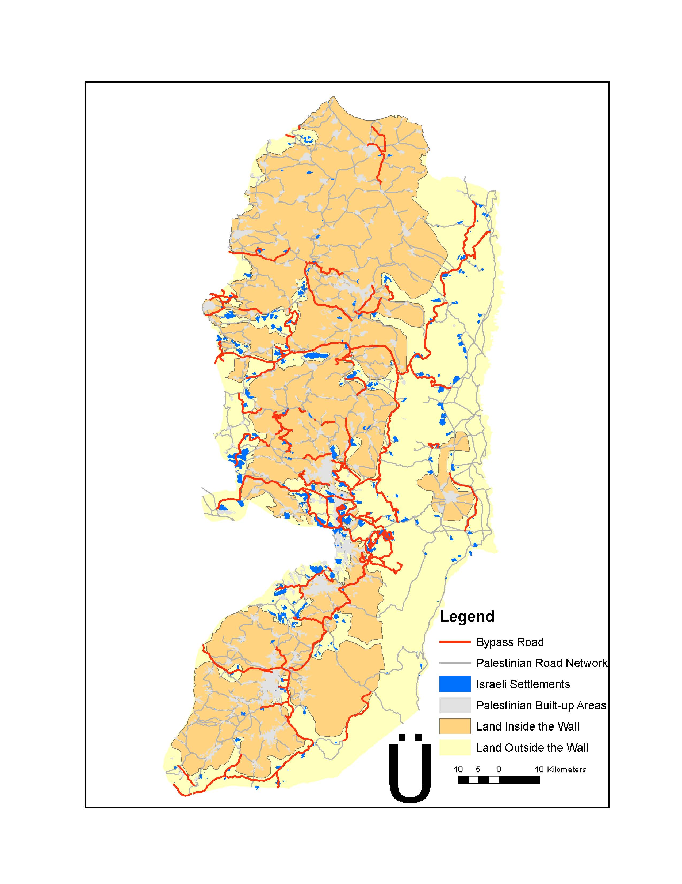
The Israeli settlements and the bypass roads
Source: ARIJ, 2004

Fig. (2)

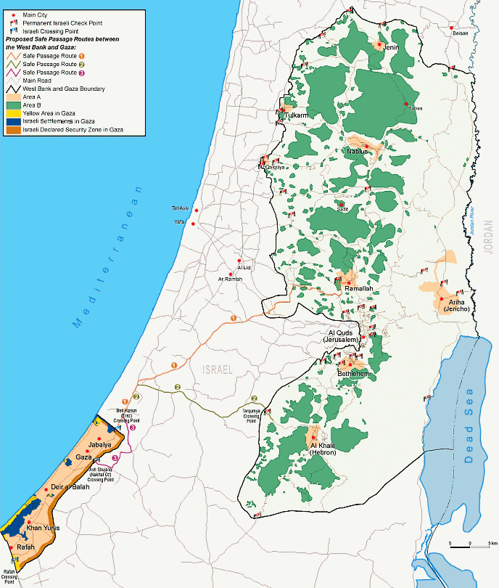

Oslo II agreement map
Source: http://i-cias.com/e.o/oslo2_ag.htm, retrieved on April 15, 2008.

Fig. (3)

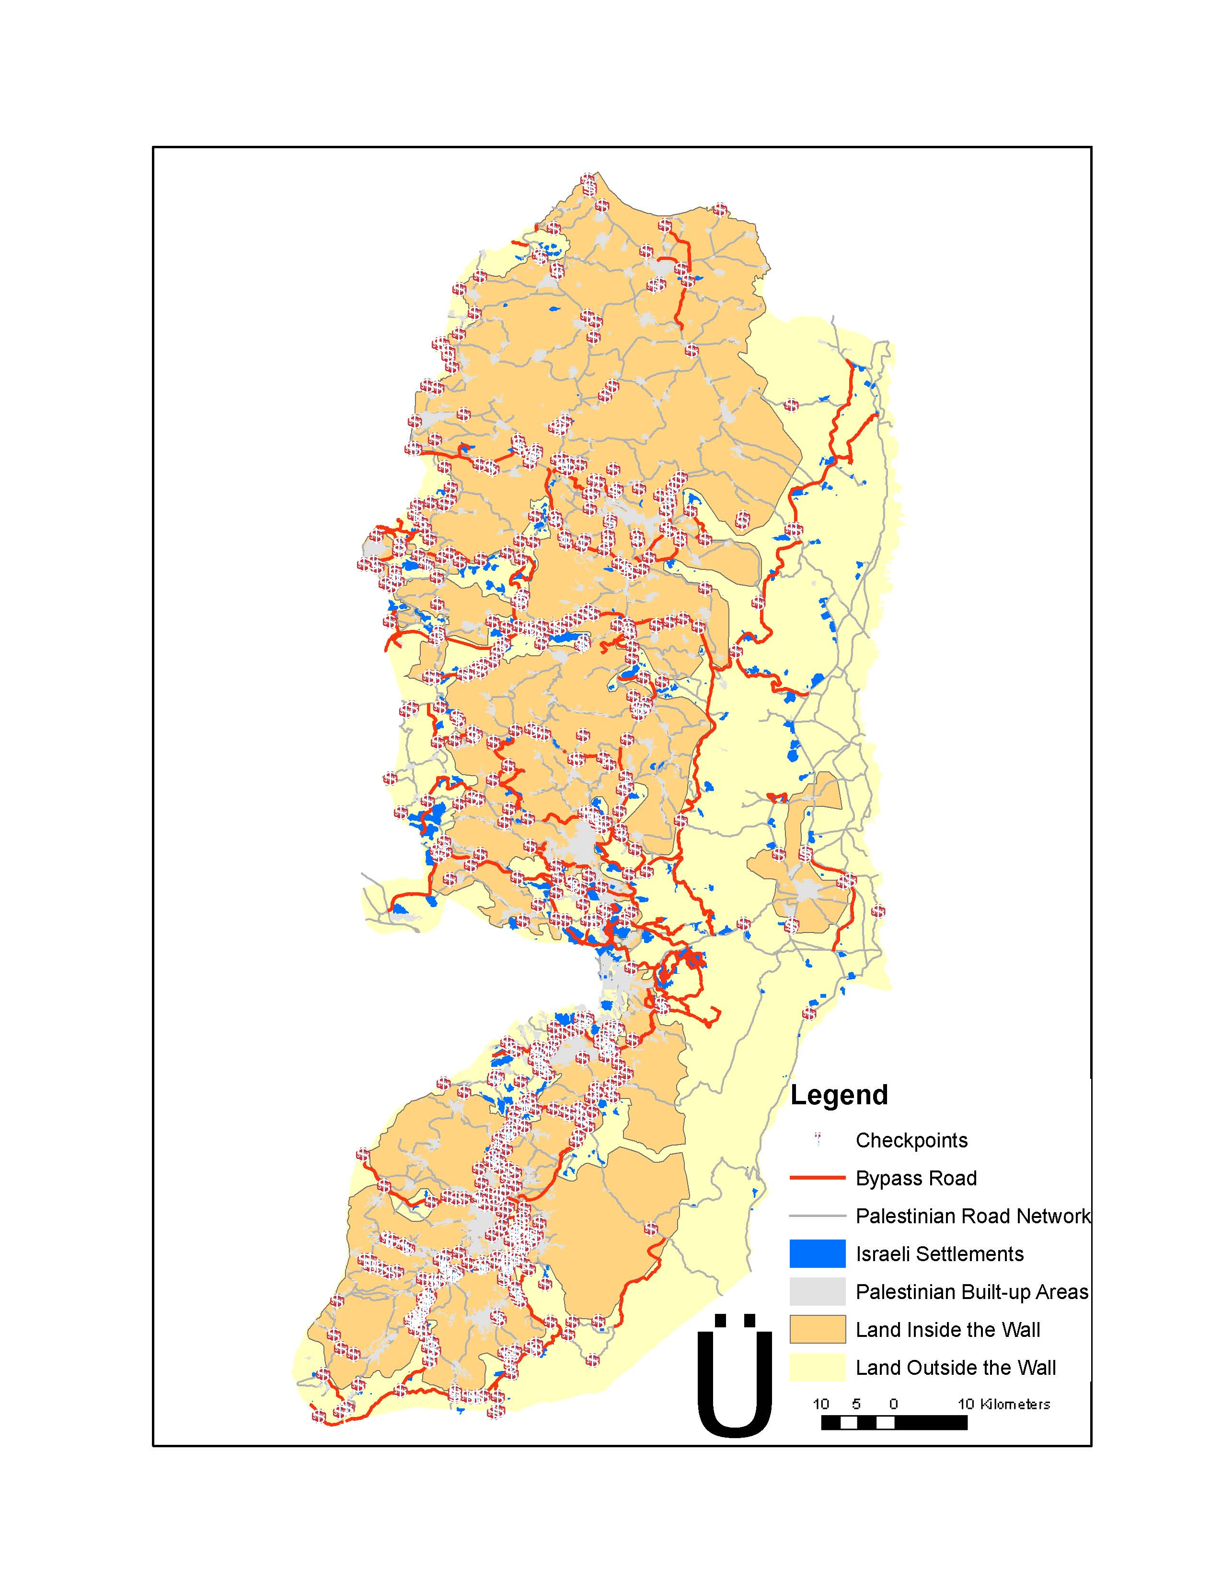
The Israeli checkpoints
Source: ARIJ, 2004
Appendix 1

Forest Reserves
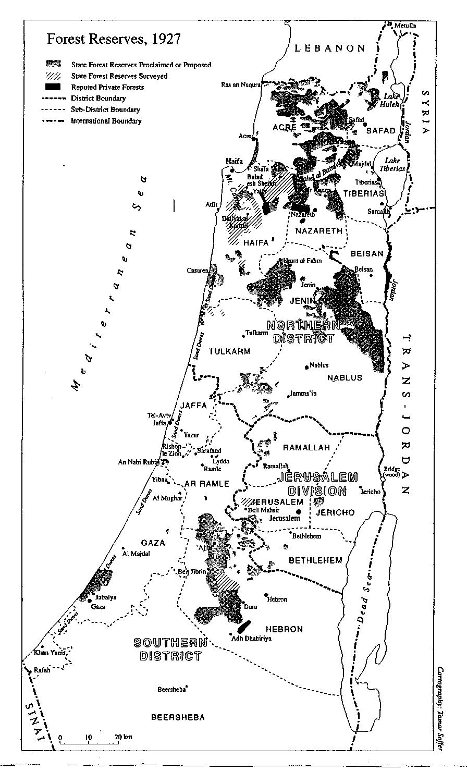

Source: El-Eini, (2006). Mandated Landscape, p. 202.

continued

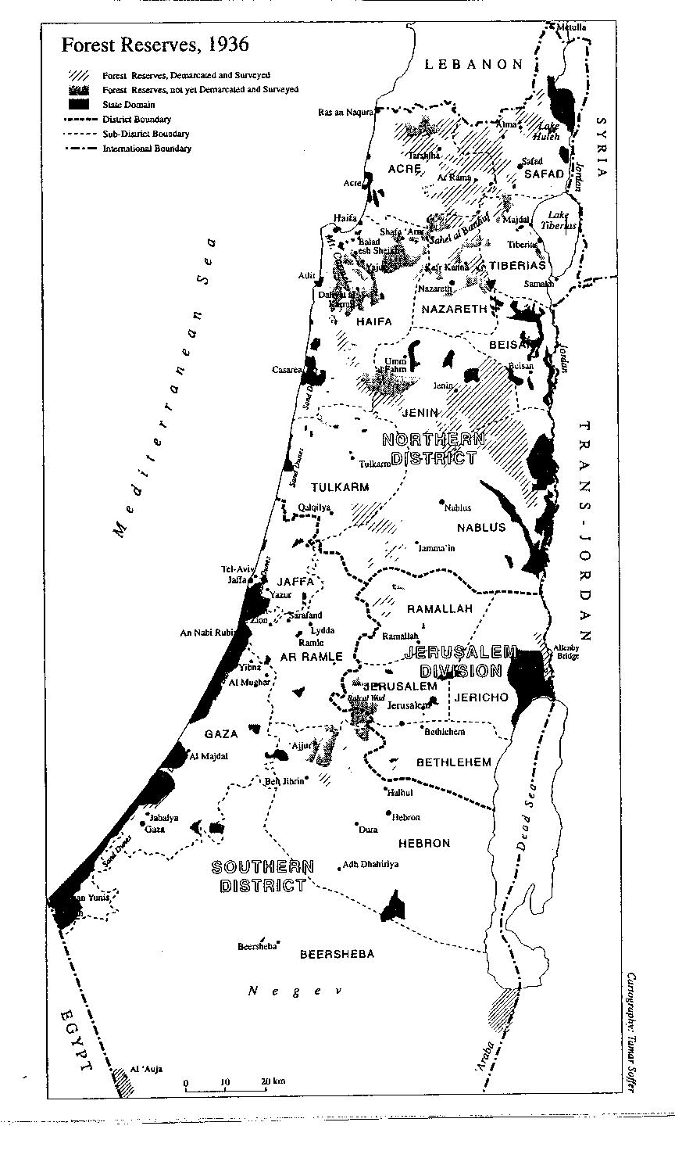

Source: El-Eini, (2006). Mandated Landscape, p. 203.

Appendix 2

Settled State Domain, 1947

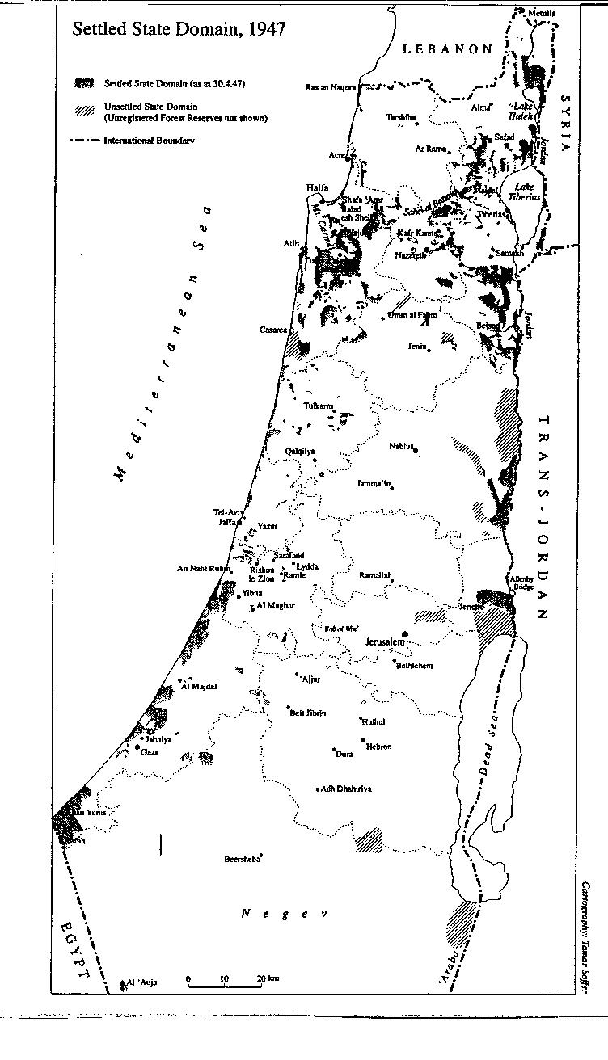
Source: El-Eini, (2006). Mandated Landscape, p. 522

Appendix 3

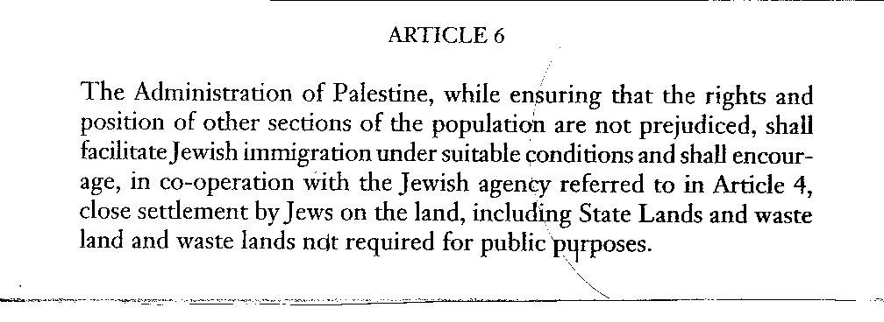

Source: El-Eini, (2006). Mandated Landscape, p. 461

Appendix 4

Total Numbers of Trees Uprooted in All Areas of the West Bank and Gaza Strip According to Tree Type During the Five Years of First Intifada

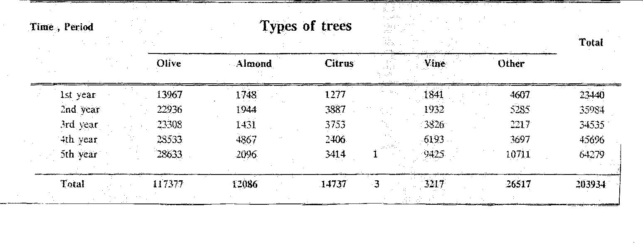
Source: Arab Studies Society & Land Research Committee, 1993, p. 16

Appendix 5

The Total Number of Uprooted Trees During the Five Years of the First Intifada

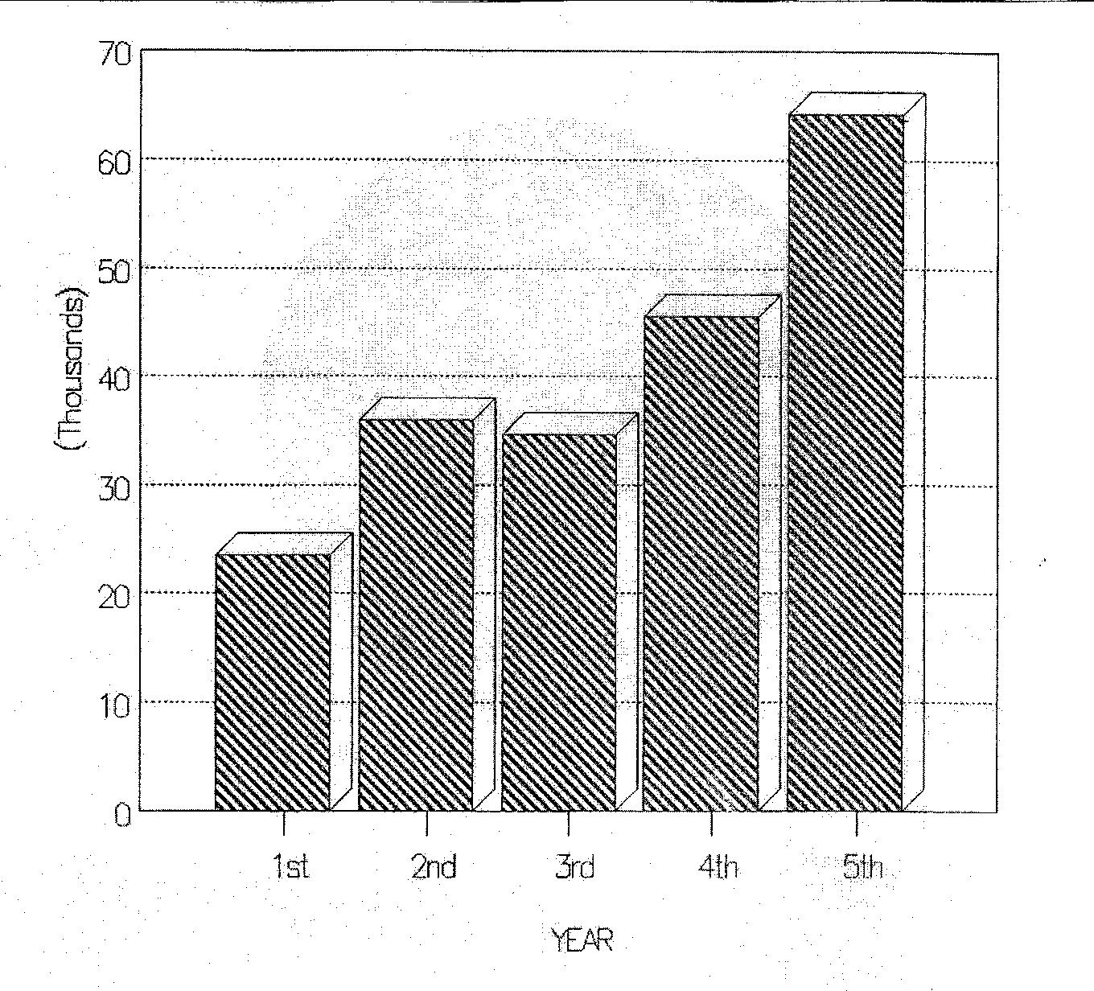
Source: Arab Studies Society & Land Research Committee, 1993, p. 17.

Appendix 6

The Percentage Tree Distribution During the Five Years of the First Intifada According to Tree Type
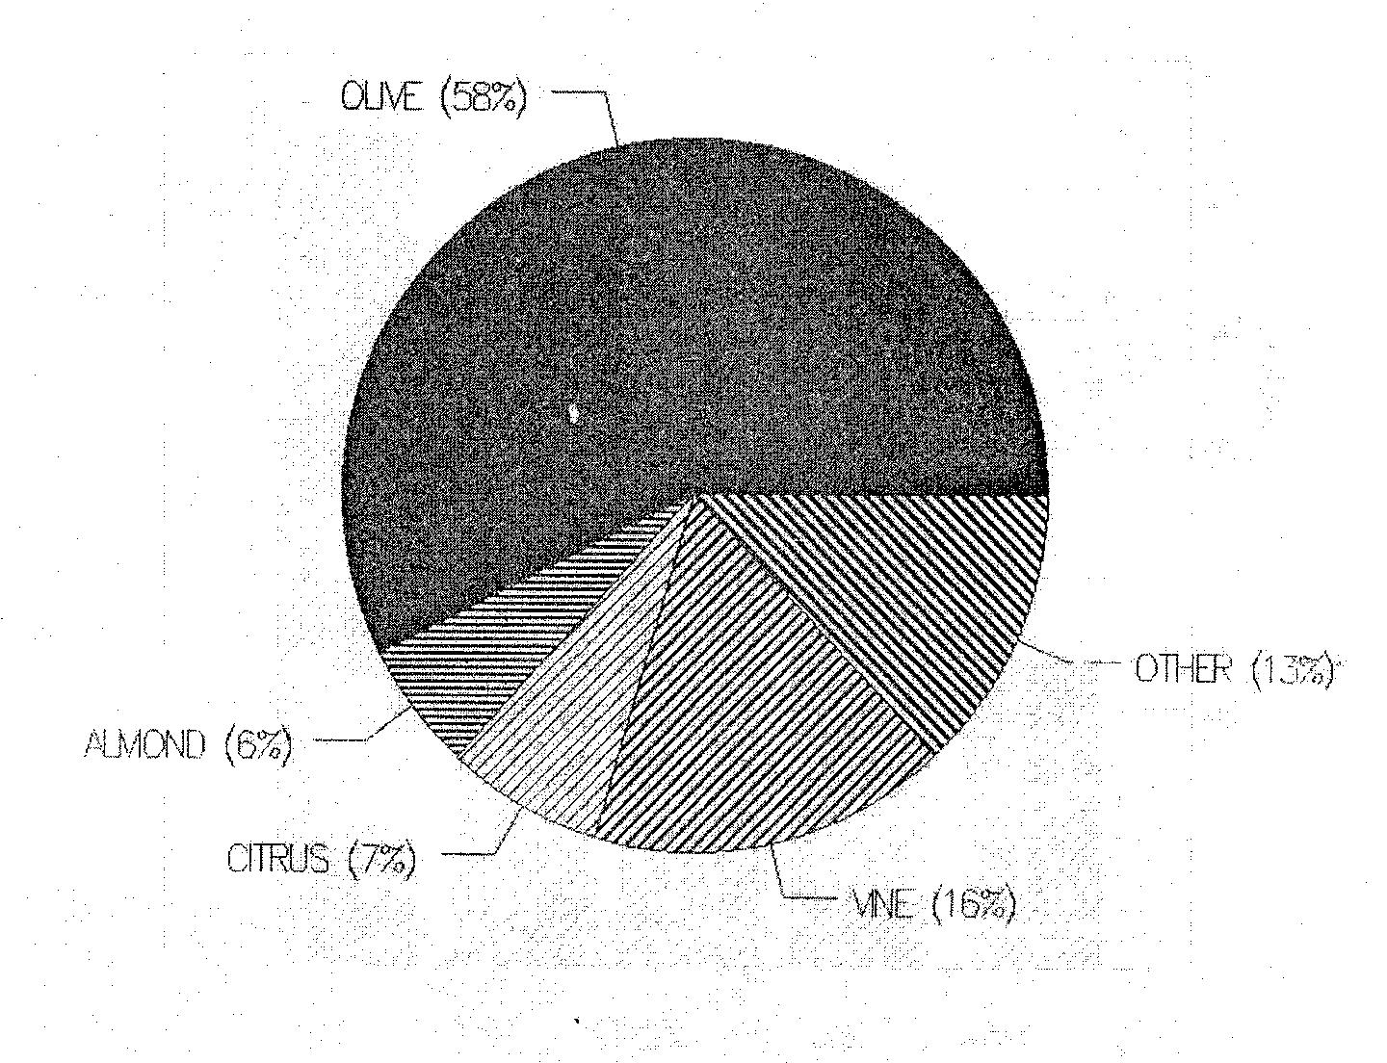
Source: Arab Studies Society & Land Research Committee, 1993, p. 18

References:
Abu-Rabia, A. (May, 2005). Bedouin Health Services in Mandated Palestine.
Middle Eastern Studies, Vol. 41, No. 3, pp. 421 – 429.

Abu-Saad, I. (2008). Spatial Transformation and Indigenous Resistance: The Urbanization of the Palestinian Bedouin in Southern Israel. American Behavioral Scientist, Vol. 51, 12, pp. 1713-1754. Retrieved March 5, 2009, from http://abs.sagepub.com at Univ. Washington Libraraies.

Agnew, J. (October, 1988). Better Thieves Than Reds’? The Nationalization Thesis and
the Possibility of a Geography of Italian Politics. Political Geography Quarterly, Vol.
7, No 4, p. 307-321.

Agnew, J & Duncan, J. (1989). The Power of Place: Bringing Together Geographical and
Social Imaginations. Unwin Hyman, Ltd., London, Sydney, Wellington.

Al-Quds Newspaper (July, 22nd, 2009). http://www.alquds.com/

Amir, S. & Rechtman, O. (2006). The Development of forest policy in Israel in the 20th Century: Implications for Future. Forest Policy and Economics, Vol. 8, pp. 35-51.

Applied Research Institute-Jerusalem (ARIJ). http://www.arij.org/index.php?option=com_frontpage&Itemid=1&lang=en.

Arab Studies Society & Land Research Committee (1993). The Agricultural Violations Through the Five Years of Intifada.

BBC News (July 21st, 2009). http://news.bbc.co.uk/go/em/fr/-/2/hi/middle_east/8160607.stm.

Beard, V. (2003). Learning Radical Planning: The Power of Collective Action.
Planning Theory, 2, 1, p. 13-35.

Bloch, M. (1964). The Historian’s Craft. Vintage books.

Cohen, S. (1993). The Politics of plantings: the Israeli-Palestinian Competition for Control of Land in the Jerusalem Periphery. The University of Chicago Press.

Cohen, S. (Jan., 1994). Greenbelts in Jerusalem and London. Geographical Review, Vol. 84, No. 1, pp. 74-89.

Collingwood R. G. (1957). The Idea of History. A Galaxy Book.

Cresswell, T. (1996). In Place/Out of Place: Geography, ideology and transgression. University of Minnesota Press, Minneapolis, London.

Davies, D. (1988). Ch. 2: The Evocative Symbolism of Trees. In The Iconography of Landscape, ed, Denis Cosgrove & Stephan Daniels (1988). Cambridge University Press.

Department of Evaluation, MoA (2006). Implemented Projects by the MoA. (Arabic)

El-Eini, R. (July 1999). British Forestry Policy in Mandate Palestine, 1929- 48: Aims and Realities. Middle Eastern Studies, Vol. 35, No. 3, pp. 72-155.

El-Eini, R. (2006). Mandated Landscape: British Imperial Rule in Palestine
1929-1948. Routledge.

Efrat, E. & Noble, A. G. (Oct., 1988). Planning Jerusalem. Geographical Review, Vol. 78, No. 4, pp. 387-404. Retrieved 06/25/2008, online, http://www.jstor.org.

Evans, J. (1948). Forestry in Palestine under the Mandate. Empire Forestry Review, Vol. 27, 2, pp. 219-226.

Falah, G. W., & Colin, F. (2004). Geopolitical Spaces: The Dialectic of Public and Private
Space in the Palestine/Israel Conflict. Arab World Geographer, Le Geographe Du Monde
Arabe, Vol. 7, No. i., p. 117-134.

Flint, C (2006). Introduction to geopolitics. Routledge, London New York.

Forbidden Roads: Israeli’s Discriminatory Road Regime in the West Bank, (2004,
August). Restrictions on Movements. Jerusalem: B’Tselem. Retrieved November 9,
2006 from B’Tselem online,http://www.btselem.org.

Goldshleger, N.; Amit-Cohen, I., & Shoshany, M. (2006). A Step Ahead of Time: Design, Allocation and Preservation of Private Open Space in the 1920s––the Case of a Garden Suburb in Israel. GeoJournal, 67, pp. 57–69.

Gregory, D. & Pred A. (2007). Violent Geographies: Fear, Terror, and Political Violence. Routledge, Taylor&Francis Group, New York, London.

Hass, A. (2002, spring). Israeli’s Closure Policy: An Ineffective Strategy of Containment
and Repression. Journal of Palestine Studies, Vol. 31, No. 3, p. 5-20.

Holston, J. (2009). Dangerous Spaces of Citizenship: Gang Talk, Rights Talk and Rule of Law in
Brazil. Planning Theory, Special Issue: Strangely Familiar, Vol. 8(1), p. 12-31.

Home, R. (2003). An Irreversible Conquest? Colonial and Postcolonial Land Law in
Israel/Palestine. Social and Legal Studies, Vol. 12, No. 3, p. 291-310. Retrieved 06/24/2008,
online, http://sls.sagepub.com.

Kark, R. & Oren-Nordheim (1996). Colonial cities in Palestine: Jerusalem under the British Mandate. Israel affairs, vol. 3, 2, pp. 50-94.
Land Reclamation Program in Economic and Agricultural Development Unit-UNDP/PAPP (2005). A Guide for Implementation of Land Reclamation Program-Participatory Natural Resources Management Program. UNDP. (Arabic)

Land Reclamation Project, MoA (n.d.). Project Evaluation in Nablus District. MoA (2006). Draft final report.

Land Research Center (LRC). http://www.lrcj.org/.

Lein, Y. (2001, January). Civilians under Siege: Restrictions on Freedom of Movement
as Collective Punishment. Restrictions on Movement, Tranz. Zui Shulman. Jerusalem:
B’tselem. Retrieved November 9, 2006 from B’Tselem online,
http://www.btselem.org.

Liggett, H. (2009). Cities and Citizens: Situating the Planning Process. Planning Theory, Special
Issue: Strangely Familiar, Vol. 8(1), p. 101-108.

Miraftab, F. & Wills, S. (2005). Insurgency and Spaces of Active Citizenship: the Story of
Western Cape Anti-eviction Campaign in South Africa. Journal of Planning Education and
Research, 25, p. 200-217.

Miraftab, F. (2006). Feminist Praxis, Citizenship and Informal politics. International Feminist
Journal of politics, 8(2), p. 194-218.

Miraftab, F. (2008). Insurgent Planning: Situating Radical Planning in the Global South.
Planning Theory, Vol. 8 (1), p. 32-49

Mitchell, D (2000). Cultural Geography: A critical Introduction. Blackwell Publishing
Ltd.

Mitchell, T. (1988). Colonizing Egypt. Cambridge University Press.

Mitchell, W. J. T. (1994). Landscape and Power. The University of Chicago Press, Chicago and London. Hahett Publishing Company, Indianapolis, Cambridge.

MoA, (2006). Draft Final Report

Nielsen, H. K., & Petersen, J. S. (2001). Middle Eastern Cities, 1900-1950: Public Places
and Public Spheres in Transformation. Aarhus: Aarhus University Press.

Palestinian National Authority (PNA). Ministry of Agriculture (MoA) http://www.moa.gov.ps/index.php.

Perera, N. (2009). People’s Spaces: Familiarization, Subject formation and emergent Spaces in
Colombo. Planning Theory, Special Issue: Strangely Familiar, Vol. 8(1), p. 51-75.

Rishmawi, K., & Safar A. (n.d.). The Impact of Israel’s Unilateral Actions on the
Palestinian Environment. ISAAC. J. Applied Research Institute- Jerusalem.

Roy, S. (2004). A Nightmare Peace: Destroying the Basis of a Palestinian State.
Palestine-Israel Journal of Politics, p. 90-95.

Roy, A. (2009a). Strangely Familiar: Planning and the Worlds of Insurgence and
Informality. Planning Theory, Special Issue: Strangely Familiar, Vol. 8(1), p. 7-11.

Roy, A. (2009b). Why India Cannot Plan its Cities: Informality, Insurgence and the Idiom of
Urbanization. Planning Theory, Special Issue: Strangely Familiar, Vol. 8(1), p. 76-87.

Sale, G. N. (1948). Note on Sand Dune Fixation. Empire Forestry Review, Vol. 27, 1, pp. 60-63.

Samara, Ali S. (September, 2006). Urban Development and Planning in the Occupied Palestinian Territories: Impacts on Urban Form. Paper presented at the Conference on Nordic and International Urban Morphology: Distinctive and Common Themes, Organized by the International Seminar on Urban Form (ISUF), Royal Institute of Technology (KTH), Stockholm, Sweden.

Sharp, J. P. & Routledge, P. & Philo, C. Paddison R. (2000). Entanglements of Power: Geographies of Domination/Resistance. Routledge, London and New York.

Tuan, Y. (1977). Space and Place: The Perspective of experience. University of
Minnesota Press. Minneapolis.

Yacobi, Haim (2004). Constructing a sense of place: architecture and the Zionist discourse. Aldershot, Hants, England; Burlington, VT: Ashgate.

Yiftachel, O. (1995). The Dark side of Modernism: Planning as Control of an Ethnic Minority. In Postmodern Cities and space, ed. S. Watson and K. Gibson. Oxford: Blackwell. p. 216-242.

Yiftachel, O. (2009). Theoretical Notes on Gray Cities: The Coming of Urban Apartheid.
Planning Theory, Special Issue: Strangely Familiar, Vol. 8(1), p. 88-100.

Zinn, H. (1990). The Politics of History. University of Illinois Press, Urbana and Chicago.

Number of geographic scholars—Agnew (1988), Agnew and Duncan (1989), Cresswell (1996), and Mitchell (2000), Tuan (1977) and Flint (2006)—distinguish between the meaning of “space” and “place”, while others—such as (Taylor, 1999)—look at both space and place as complementary: the meanings of space and place either cannot be defined or explained without explaining or defining the other. This paper does not focus on the difference between them and deals with space in its complementary with place.
As a kind of punishment, the Israeli occupation used to use the policy of demolition the Palestinians’ buildings; houses or other kinds of buildings. This punishment stems from the understanding of the Israeli occupation of the symbolic meaning of the “house” for the Palestinians. Palestinians have great connection with their houses. The house for the Palestinian does not only mean a shelter. Rather it also reminds of the place of fathers and grandfathers and the future place of children. Additionally, the Israeli occupation, especially after the land division into A, B, and C zones through Oslo II agreement, used to restrict any new building. New buildings should have a permission from the Israeli authorities in areas B and C. this means to go into an endless process which usually ends with refusal.
Oslo II agreement was between the Palestinians and Israel. It is signed September 24, 1995, in Washington, USA, by the chairman of PLO, Yassir Arafat, the Israeli Prime Minister, Yitzhak Rabin and the president of USA, Bill Clinton. This agreement was a follow up of the Oslo Agreement from two years earlier, the first peace agreement between Israel and Palestine and served as a continuation of the fragile peace process of the Middle East. The actual content of the Oslo II, concerned the West Bank, and covered security issues, Palestinian elections, transfer of land, transfer of civil power from Israel to Palestine, trade conditions between the two countries and release of Palestinian prisoners from Israeli prisons. Through this agreement, the West Bank was divided into A, B, and C zones, which are of different status regarding the nature of security control over them (area A, where most Palestinians live, has full Palestinian security and Palestinian civil control; area B has Israeli security and Palestinian civil control; and area C under full Israeli control, and by September 2000 the area A totaled 18%, whereas area C 60%) For more see Looklex Encyclopedia: http://i-cias.com/e.o/oslo2_ag.htm, and (Hass, 2002).
The Israelis benefited from the inherited Ottoman land law, which forms the basis for different legal systems pertaining to the area, legitimacy is ascribed to those who can demonstrate presence on the land (Cohen, 1993).
It applies the Absentee Property Law that was passed by the Knesset in March 1950. By defining the term Absentee, vast expropriation of Palestinian land was made possible by the Israeli state (Meishar, in eds. Haim Yacobi, 2004, p. 322).
This anti-afforestation policy mainly used by the Israeli authorities during the late period of the occupation, and specifically one can say that this is the case of the current afforestation policy of the Israeli occupation towards the PT as we’ll see in the coming section.
Till June 2003, the number of trees that had been cut or uprooted for building the Israeli Wall reached to 803,978 trees, of which 234, 830 are olive trees (MoA, 2003). As a result of Israeli land confiscation, the West Bank losses from September 2000 to April 2005 include: 13,000 dunams of fruit trees, 270 dunams of green houses, and 15,000 dunams of fruits and vegetables in open fields (UNDP/PAPP, 2005).
Such Palestinian organizations are: Land Research Center (LRC), Juhoud, Al-Khader Cooperation, Jenin Cooperation, Ma’an Development Center, Payesan Union (PU), Union of Agriculture Working Committee (UAWC), Economic & Social Development Center (ESDC), Palestinian Agriculture Relief Committee (PARC), Arab Center for Agricultural development (ACAD), and Union of Agriculture Working Committee (UAWC).
Such as International Fund for Agricultural development (IFAD), Program of Assistance to the Palestinian People (PAPP), and United Nations Development Program (UNDP), and other foreign organizations from Japan and from Europe such as Spain and Italy.

